[Ambassador Extraordinary and Plenipotentiary of India to Ukraine Visited TNMU](https://www.tdmu.edu.ua/int/ambassador-extraordinary-and-plenipotentiary-of-india-to-ukraine-visited-tnmu/)

On October 10, 2024, the Ambassador Extraordinary and Plenipotentiary of India to Ukraine Ravi Shankar paid a working visit to Ternopil National Medical University. He met with the Rector of TNMU, Professor Mykhaylo Korda, Vice – Rector for Research, Professor Ivan Klishch, Dean of the International Students’ Faculty, Professor Mariya Marushchak.

The participants of the meeting discussed the issues of the education of students from India at Ternopil National Medical University, as well as the broadening cooperation in the field of medical education and research.

Rector Mykhaylo Korda spoke in detail about the achievements of the University in recent years, its scientific accomplishments and technical facilities.

Students from India prepared a small concert during which they presented the diversity of Indian culture, its literary and spiritual heritage, as well as the traditions and artistic heritage of Ukraine.

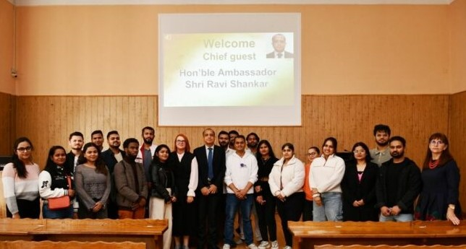

The distinguished guest had the opportunity to personally see the work of the educational centers and the Centre for Medical Stimulation, as well as the library of TNMU.

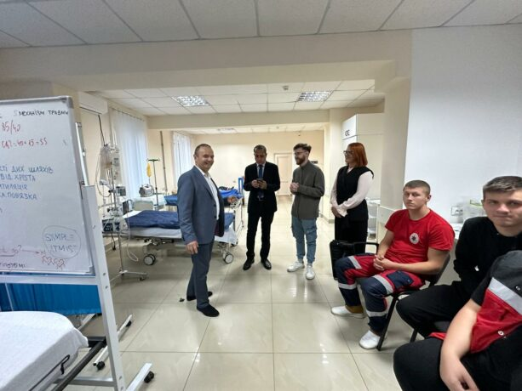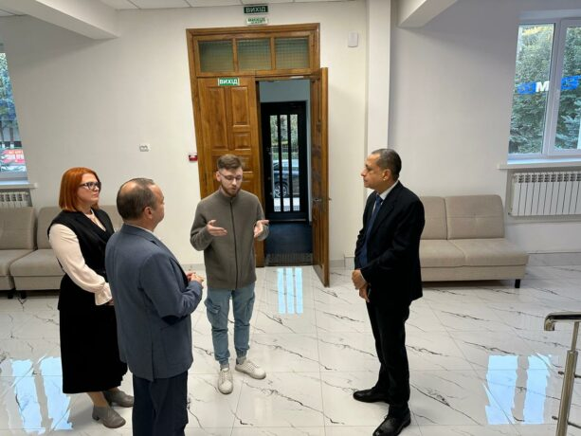

Our students express their thanks to the Ambassador Extraordinary and Plenipotentiary of India to Ukraine Ravi Shankar for his attention to their questions.