All-Ukrainian Action “16 days to fight against violence” meeting.

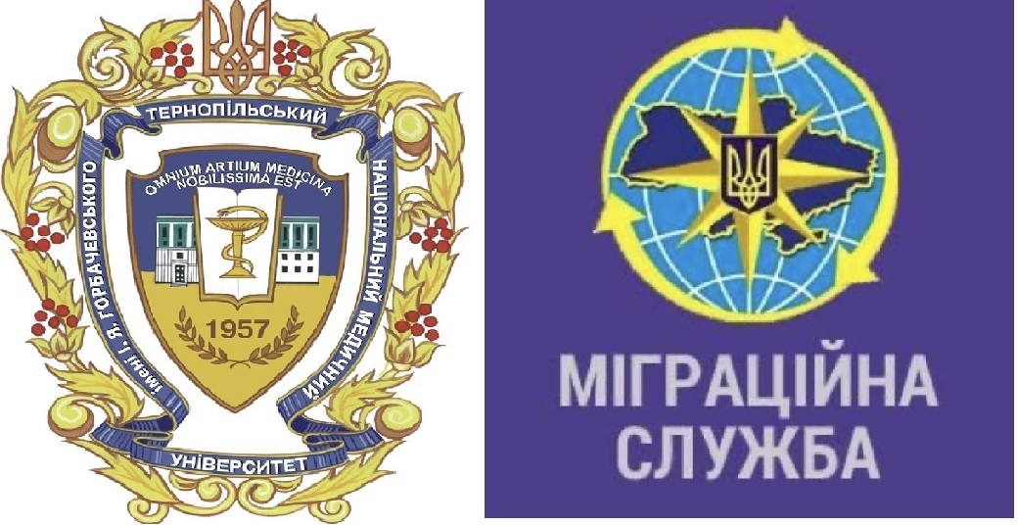

Dean’s office of International Students Faculty, together with the State Immigration Service of Ukraine in Ternopil region, carried out an online ZOOM meeting dedicated to the All-Ukrainian Action “16 days fighting against violence and abuse” on November, 27, 2024.

The All-Ukrainian Action starts every year from November, 25, and lasts exactly for sixteen days, and during this period special emphasis is paid to raise awareness about the issue.

The Deputy Chief of State Immigration Service of Ukraine in Ternopil region, Ms. Tetiana Lobach, presented useful information to all international students on how to confront and react against violence and abuse, including cyberbullying. She provided useful contact information on how to reach governmental services to inform about potential violence acts.

The international students from TNMU took an active participation and asked many related questions, supporting the initiative and helping the community of the Ternopil region.